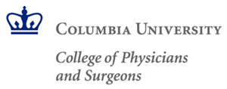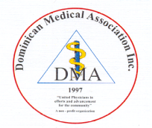
Save the Date

The Dominican Medical Association (DMA)
XIII Medical Symposium

Clinical Guidelines for the Diagnosis, Evaluation, Treatment and Referral of Common Conditions in the Primary Care Setting

A Columbia-accredited program, featuring faculty from
Columbia University College of Physicians & Surgeons
Co-sponsored by Columbia University College of Physicians & Surgeons and
NewYork-Presbyterian’s Allen Hospital, Ambulatory Care Network, and Office of External Relations

7:00am – 4:00pm, Sunday, April 19, 2015
The Morgan Stanley Children’s Hospital of NewYork-Presbyterian
3959 Broadway (165th Street)
New York City 10032

The following lectures have been confirmed to date:
Evaristo Akerele, MD – Schizophrenia & Substance Abuse
Deepthiman K. Gowda, MD, MPH – Update on Cancer Screening
Jose A. Luchsinger, MD, MPH – Update on Diagnosis, Prevention, and Treatment of Alzheimer’s Disease and Other Dementias
Wilson A. Quezada, MD – COPD: Practical Management in 2015
Joseph Tenenbaum, MD – Lipids – Stray from the Guidelines?

Updates will be provided as lectures and speakers are confirmed
For inquiries and registration information, call
Dr. Leonardo Paula at 917-259-8520

