
Asociacion Hispana de Profesionales de la Salud Inc,NY.

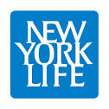
Desfile y Festival Dominicano de Union,New Jersey.
The Rejuvee™
Institute,, Dr.Tony de la Rosa
Health Care training, Institute,
Union

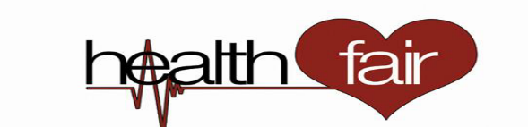



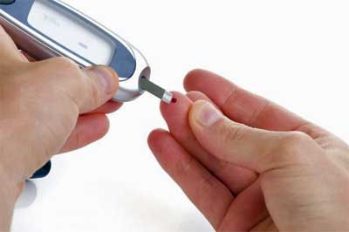

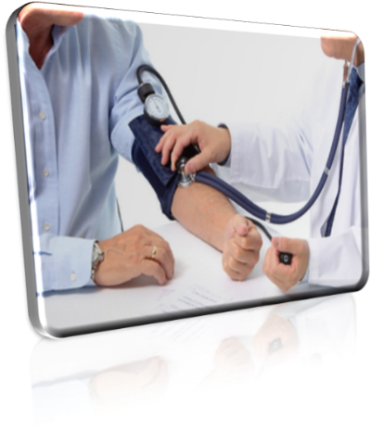

HEALTH INFORMATION - FREE HEALTH SCREENING
Prostate, Colorectal & Breast, Cancer Awareness
Diabetes, High Blood Pressure, Cholesterol Awareness
Dental Screening, Allergies Awarenes Family Planning/Youth Program and Good Nutrition,Massage, Psicological Counseling.
- BLOOD PRESSURE SCREENING
- GLUCOSE SCREENING
- BODY MASS INDEX (BMI) SCREENING

V ANNUAL FERIA DE LA SALUD DE ELIZABETH,NJ- GRATIS
Sunday,August 16^{th,} 2015

School #28, Juan PabloDuarte-Jose Julian Marti- 25 First St.
Elizabeth, New Jersey,07206

10:00 a.m. - 4:00 p.m.
For moreinformation:
1-888-277-1288, 917-403-9220. info@ahpsi.org

