Colegio Medico Dominicano Filial New England -Boston.

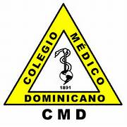

And AHPSI

Hispanic Health Professionals Association, Inc NY.
Over 27 Years.

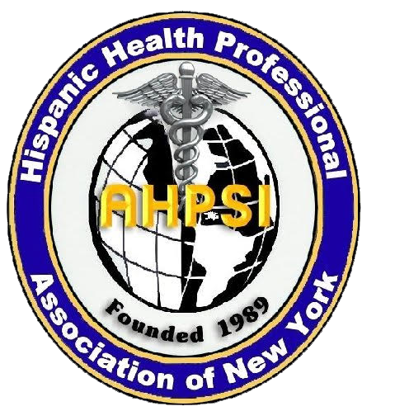

AHPSI

VI Annual International Medical Congress.
DOUBLE TREE BY HILTON HOTEL
123 Old River Road ,Andover,MA, 01810
Time: 8am- 4:30 pm.

Preliminary program:

Medical Congress Program:
Sunday,4, December , 2016
7:30:a.m. Registration; Continental Breakfast

Moderator: Dra Andrea Familia.
8:20 a.m. Welcome: Dra.Fidelina Santiago,President CMD- Boston.
8:30 a.m. USMLE, Dentistry Board Vs. Latino immigrant Health Professionals in USA.
Dra.Mildred Rivera, Ahpsi,USMLE Academy.
9:10 a.m. " La medicina moderna en sus inicios"
Dr.Giordano Encarnacion.

9:40: a.m Social Media & Crowdourcing,para el avance profesional y el cuidado de la Salud.
Social Media & Crowdsourcing for advancement health professionals and health care.
Claritza Abreu, Profesor Cambridge College.

Questions and Answers.

Moderator Dra.Alida Jimenez.

10:40 Update in Neurologic infectious diseases
Carlos Williams, MD.

11:15 am. Up date Tropical Diseases.
Clemente Terrero, MD.

12;3O Pm. Complications for infections in plastic surgery
Dr.Roberto Guerrero, Plastic Surgeon.

Moderator : Dr.Nilvio del Rosario.

1:00 p.m. Networking Lunch. & Award Ceremony.

Derma compare & Ahpsi present "Skin Cancer ,call to action ,New app for Early detection"
By Ines Tejada ,RN,MSN,MEd,MA.

Felipe Fregni, MD Harvard University.What is? Principles and Practice of Clinical Research (PPCR]
Dr.Victor Escalante,MD, Surgical Assistant Program.
Dr.Rafael Munoz, founder CMD New England, Salutation.
Lifetime Community Appreciation Award, Dr.Noemi Custodia Lora.
Outstanding Health care professional award. Nicte Mejia,MD
Lifetime Achievement Award, Analuz Garcia.
Lifetime Health Care Professional Award. Patrick Marasko.
Ouststanding Health care professional award, Dr.Roberto Guerrero.
Lifetime community Appreciation Award, Dr.Mauro Canario Lorenzo.

Moderator :Dra.Josefa Mateo.

2:00: Jose Baez. MD, & Patrick Marasko, Plastic Surgeon

Update Prevention of infections in diabetic ulcers.

3:oo PM Keynote Lecture: Situacion actual de Salud, en la Republica Dominicana,Enfasis Enfermedades Infecciosas.

Current state of health in the Dominican Republic, Enfasis Infectious Diseases.
Dr.Mauro Canario Lorenzo.

Closing Remarks/Adjournment:

Meeting Location: Double Tree By Hilton Hotel Boston-Andover-
123 Old River Road, Andover, MA, 01810.

Acknowledgement:
Executive planning Committee:

Dra.Fidelina Santiago
Dra.Leonor Tavarez.
Dr.Rafael Muñoz,
Dra.Josefa Mateo.
Dra.Andrea Familia.
Dra.Maria Puente.
Profesora Claritza Abreu,
Dra.Martires Luciano,
Dra.Leonarda Rodriguez
Dra.Marleny Sarante.
Dra.Elba Florian.
Dr.Diogenes Fermin,
Licda.Leonidas Santos,
Dra.Aritmedes Restituyo
Ines Tejada,RN.
Dra Alida Jimenez.

Special thanks to our sponsors.
Thanks to our Sponsors.

Medicoop.
Derma Compare.
Dr.Jose Baez.
Dr.Roberto Feliz.
Dr.Jose Deleon. Podiatry.
Dr.Fernando Taveras, Psiquiatra,Centro Medico Dominicano.
Dr.Roberto Guerrero.
Centro Medico Dominicano , Dr.Fernando Taveras.
Briggs Family pediatrics, Dra.Carmen Librada Lazala.
Xeron Laboratory,NY
First Step Medical PC-Maria M. Molina, MD
Ola Pediatrics, Dra.Ana Rita Olivero.
Dr.Jorge Cornielle, Pediatra.
UMO Medical “Christian Belliard, MD
Medikids Pediatrics”Marcial Jimenez ,MD
Pediatrics 2000 lll PLLC ,”Dr. Marino Torres, MD, FAAP
NY Physical Therapy & Orthopedic Medical Pavilion ”Fresia Olivero”
Dr.Juan Collado, DDS.
Dr.Angel Alcantara,MD.
Dr.Fernando Taveras. Psiquiatra.
Dr.Marcial Jimenez,MD
St.Teresa Pharmacy
Howard Rosas, D.P.M.,D.A.B.P.O
Te casa
Special thanks to elected officials :

Hon.Marcos Devers. Massachusetts
Hon Adriano Espaillat. NY Senate.
Hon.Mayor Lawrence ,MA, Daniel Rivera.

