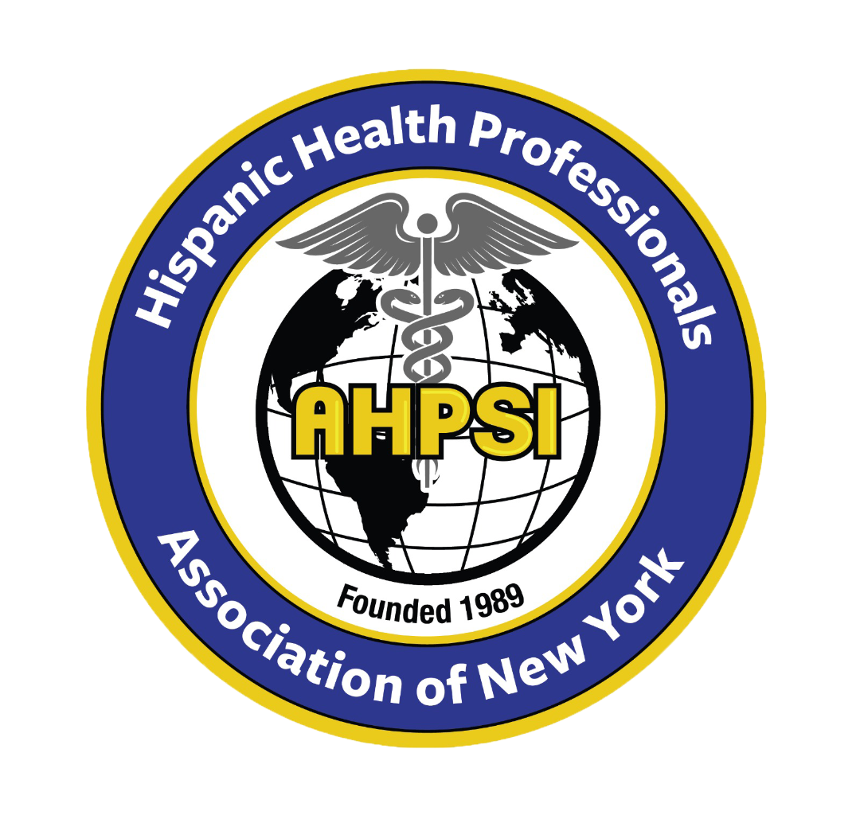  Dr.Aritmedes Restituyo.  President  Eliscer Guzman,MD  President ad vitam.  Carlos Williams, MD  Chairman  Licda.Paulina De León.  Miembro  Dra.Leonor Tavarez.  Member.  Dra.Carmen Rodriguez.  Member.  Dr.Cristian De Leon.  Dominican Republic,  Representative.  Licda.Genny Jimenez.  Licda.Elba Rosa Garcia.  Secretary.  732-277-9640  resti1@aol.com  info@ahpsi.org | Hispanic Health professionals association, Inc NY  Over 35 years of service.  March, 7, 2024  To: Collaborator  New York, NY  Dear Dr……  On behalf of the Hispanic Health Professionals Association, Inc. NY (AHPSI), we cordially invite you to participate in our XVIII Annual Multidisciplinary International Medical Congress, to be held on May 5, 2024, from 8 AM to 4 PM, at the Cherkasky Auditorium at Montefiore Hospital, 110 East 210th St, Bronx, NY 10467.  The central theme of this year's congress is "The Impact of Climate Change on Physical and Mental Health: Global and Local Perspectives." This event will bring together experts from various fields to discuss the profound effects of climate change on human health and explore strategies to mitigate these impacts.  With great pride, we announce that as we have done every year, we will include a panel dedicated to assisting professionals who have graduated abroad in the areas of medicine and nursing, guiding them through the process of obtaining their licenses.  We kindly request your financial support for this important event. Your contribution will be instrumental in covering expenses such as advertising, venue rental, and other associated costs. In a separate document, you will receive detailed information about the different levels of sponsorship available.  Your annual collaboration has been invaluable to the success of our medical congress, and we extend our sincere gratitude for your continued support. Together, we can raise awareness and promote solutions to address the pressing issue of climate change's impact on physical and mental health.  Thank you for your consideration, and we look forward to your participation in this significant endeavor.  Sincerely,  Dr. Aritmedes Restituyo  Hispanic Health Professionals Association, Inc. NY (AHPSI)  info@ahpsi.org  732-277-9640

