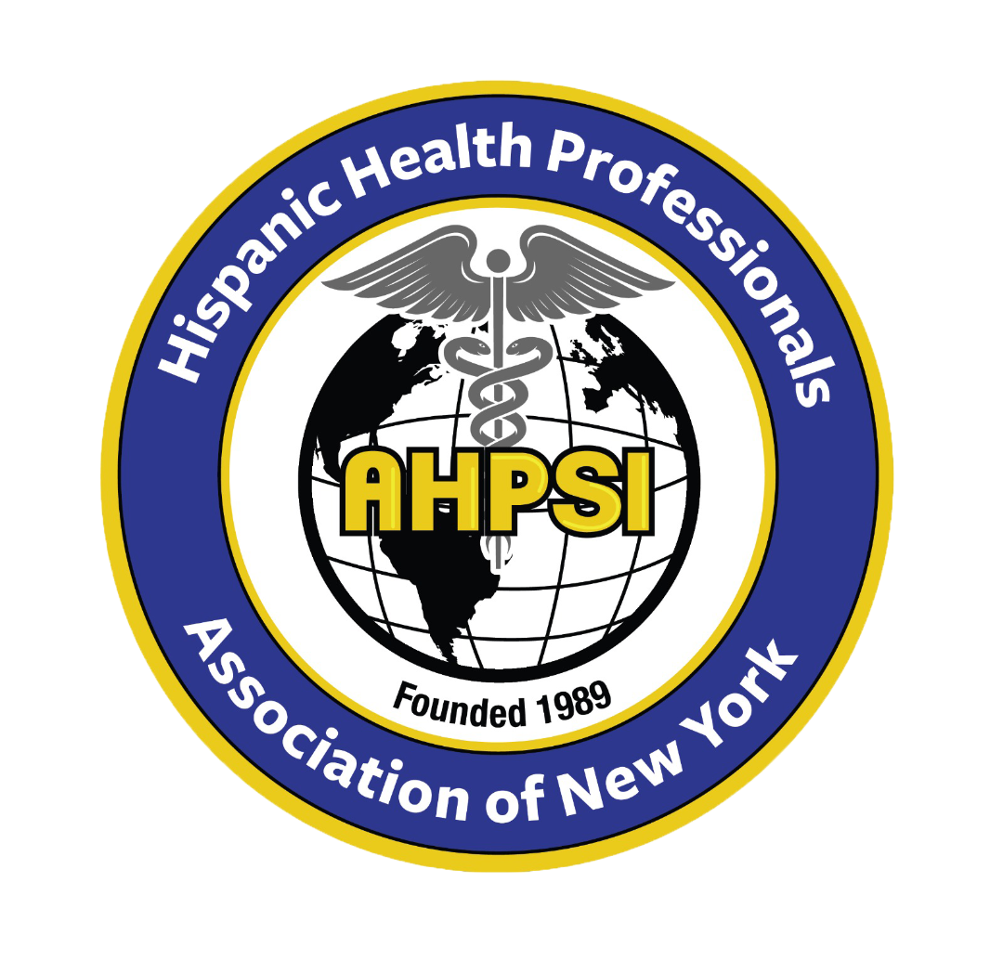  Dr.Aritmedes Restituyo.  President  Eliscer Guzman,MD  President ad vitam.  Carlos Williams, MD  Chairman  Licda.Paulina De León.  Miembro  Dra.Leonor Tavarez.  Member.  Dra.Carmen Rodriguez.  Member.  Dr.Cristian De Leon.  Dominican Republic,  Representative.  Dr.Alexander Mendieta  Dra.Jennifer Matos.  Licda.Genny Jimenez.  Licda.Elba Rosa Garcia.  Secretary.  732-277-9640  resti1@aol.com  info@ahpsi.org | Hispanic Health professionals association, Inc NY  Over 35 years of service.  April, 14, 2024  Open Letter to Health Professionals in New York, New Jersey and Other Cities  Dear health professionals:  With great enthusiasm, we invite you to participate in our XVIII Annual International Medical Congress, organized by the Hispanic Association of Health Professionals, Inc. NY (AHPSI).  This event will take place on May 5, 2024 at the Cherkasky Auditorium, Montefiore Hospital, located at 110 East 210th St, Bronx, NY 10467.  This year, our congress addresses a topic of urgent relevance: "The Impact of Climate Change on Physical and Mental Health: Global and Local Perspectives." Together, we will explore the challenges and solutions to the adverse effects of climate change on our health and environment, a concern that affects us both globally and locally.  The event will also include specialized sessions, such as an interactive workshop dedicated to nurses preparing for the NCLEX-RN exam, as well as panel discussions on exam preparation in Medicine and Dentistry. Additionally, we will have the honor of presenting the 8th Dr. Marcos Charles Santana Health Legacy Award, in recognition of dedication and legacy in the field of health.  This congress will not only be a platform for the exchange of knowledge and experiences, but also a unique opportunity to strengthen our professional and personal networks. It is a not-to-be-missed event for those committed to advancing public health and community well-being.  We encourage you to register and be part of this enriching experience. For more information, you can contact Dr. Aritmedes Restituyo by email at innfo@ahpsi.org, or by phone at 732-277-9640.  We look forward to his valuable presence to explore and discuss how we can, together, address one of the greatest challenges of our era.  With appreciation and respect,  Dr. Aritmedes Restituyo  Hispanic Health Professionals Association, Inc. NY (AHPSI)

