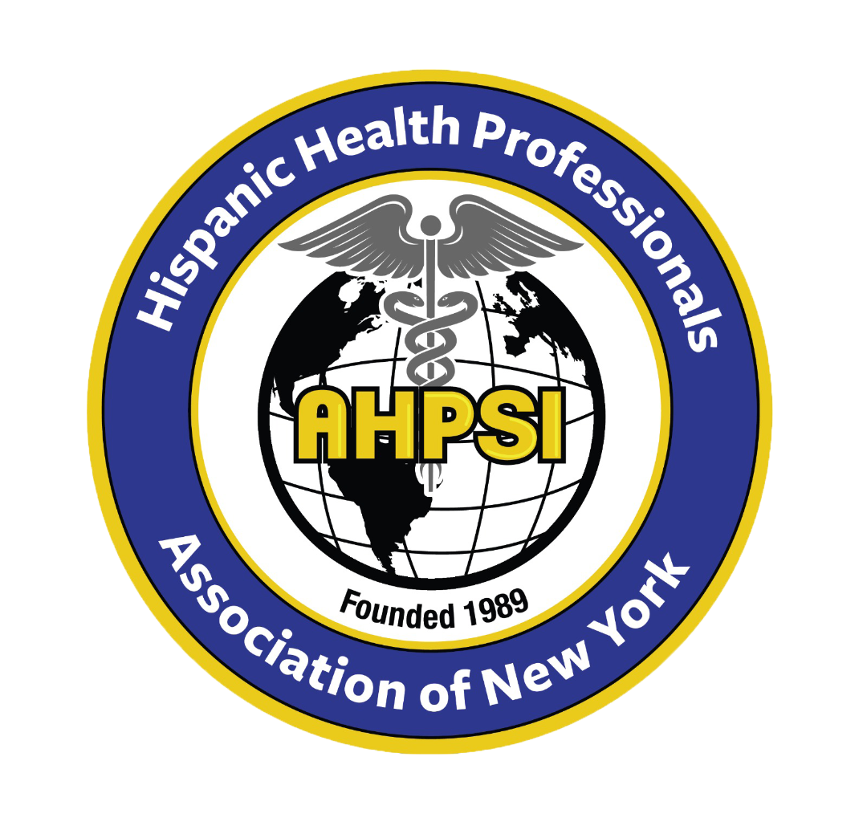  Dr.Aritmedes Restituyo.  President  Eliscer Guzman,MD  President ad vitam.  Carlos Williams, MD  Chairman  Licda.Paulina De León.  Miembro  Dra.Leonor Tavarez.  Member.  Dra.Carmen Rodriguez.  Member.  Dr.Cristian De Leon.  Dominican Republic,  Representative.  Dr.Alexander Mendieta  Dr.Jennifer Matos  Licda.Genny Jimenez.  Licda.Elba Rosa Garcia.  Secretary.  732-277-9640  resti1@aol.com  info@ahpsi.org  Dr.Aritmedes Restituyo.  President  Eliscer Guzman,MD  President ad vitam.  Carlos Williams, MD  Chairman  Licda.Paulina De León.  Miembro  Dra.Leonor Tavarez.  Member.  Dra.Carmen Rodriguez.  Member.  Dr.Cristian De Leon.  Dominican Republic,  Representative.  Dr.Alexander Mendieta  Dra.Jennifer Matos  Licda.Genny Jimenez.  Licda.Elba Rosa Garcia.  Secretary.  732-277-9640  resti1@aol.com  info@ahpsi.org |  | Hispanic Health professionals association, Inc NY  Over 35 years of service.  April , 4, 2024  XVIII Annual Multidisciplinary international medical congress,NY.  Sponsorship Proposal  Central Theme: The Impact of Climate Change on Physical and Mental Health: Global and Local Perspectives  Introduction:  Climate change is one of the greatest challenges facing humanity, and its effects on human health are becoming increasingly evident. The Hispanic Health Professionals Association, Inc. NY (AHPSI), with over 35 years of service, is organizing a medical congress to analyze the impact of climate change on physical and mental health from global and local perspectives.  Brief Explanation:  Human activities, such as burning fossil fuels, deforestation, and industrial processes, have significantly contributed to the increase of greenhouse gas emissions in the atmosphere. These gases trap heat from the sun, causing a gradual rise in global temperatures, which leads to various environmental changes, including rising sea levels, melting glaciers, and more frequent and severe weather events. These changes in the Earth's climate have far-reaching consequences on human health, both physical and mental.  Congress Overview:  This medical congress will bring together local experts from New York City, other states, and countries to discuss the impact of climate change on physical and mental health. Participants will explore strategies and solutions to mitigate the effects of climate change and promote sustainable practices in the healthcare industry.  Venue: Cherkasky Auditorium at Montefiore Hospital, 110 East 210th St, Bronx, NY 10467  Date: May 5, 2024  Time: 8 AM - 4 PM  Sponsorship Opportunities:  1.Diamond Sponsor ($2,000)  - Prominent logo placement on all event materials  - Opportunity to address the audience and distribute promotional materials  - Recognition on AHPSI's website and social media channels  - 5 complimentary event registrations  2.Platinum Sponsor ($1,000)  - Logo placement on event materials  - Recognition on AHPSI's website and social media channels  - 3 complimentary event registrations  3.Gold Sponsor ($500)  - Logo placement on event materials  - Recognition on AHPSI's website  - 2 complimentary event registrations  4.Bronze Sponsor ($300)  - Name recognition on event materials  - Recognition on AHPSI's website  - 1 complimentary event registration  Please make checks payable to: Hispanic Health Professionals Association, Inc. NY (AHPSI)  Your support and participation in this medical congress will contribute to raising awareness and promoting solutions to address the impact of climate change on physical and mental health, locally and globally.  Contact Information:  Dr. Aritmedes Restituyo  info@ahpsi.org  732-277-9640

