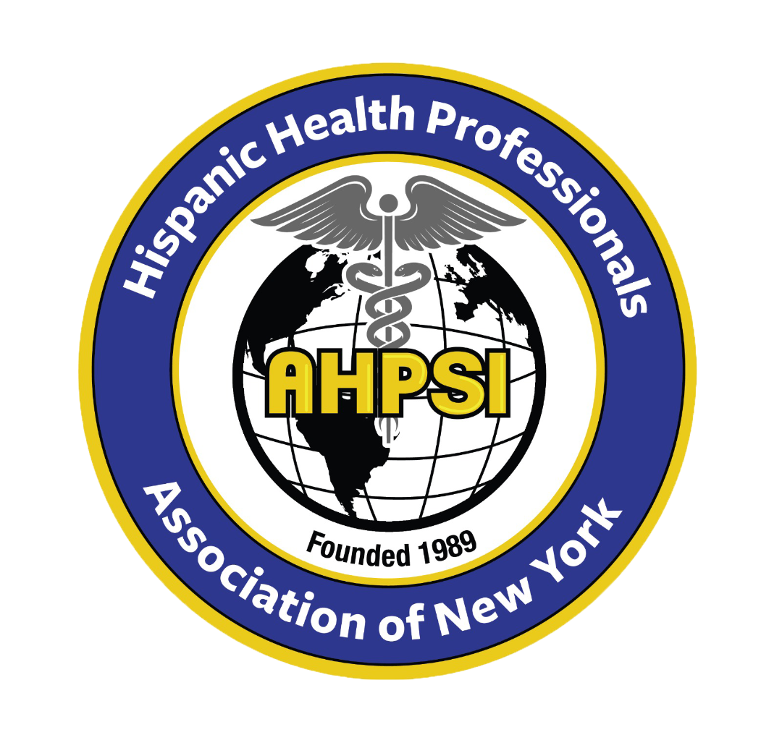  Dr.Aritmedes Restituyo.  President  Eliscer Guzman,MD  President ad vitam.  Carlos Williams, MD  Chairman  Licda.Paulina De León.  Miembro  Dra.Leonor Tavarez.  Member.  Dra.Carmen Rodriguez.  Member.  Dr.Cristian De Leon.  Dominican Republic,  Representative.  Dr.Alexander Mendieta  Dra.Jennifer Matos.  Licda.Genny Jimenez.  Licda.Elba Rosa Garcia.  Secretary.  732-277-9640  resti1@aol.com  info@ahpsi.org | Hispanic Health professionals association, Inc NY  Over 35 years of service.  April 8, 2024.  Dear Distinguished Sponsors and Members,  On behalf of the Hispanic Association of Health Professionals and the organizing committee, we are writing to request your generous financial support for the XVII Annual International Medical Congress. This year's central theme is "The Impact of Climate Change on Physical and Mental Health: Global and Local Perspectives," which promises to be an insightful and thought-provoking exploration of a pressing global issue.  The congress will be held on Sunday, May 5, 2024, from 8 a.m. to 4 p.m., at the Cherkasky Auditorium at Montefiore Hospital, located at 110 East 210th St, Bronx, NY 10467. As is customary, we will include a round table discussion on how immigrant health professionals can prepare for their licensing exams in medicine, nursing, and dentistry.  We are honored to announce the VIII Annual Dr. Marcos Charles Santana Health Legacy Award, which celebrates the remarkable 54-year career and contributions of Dr. Marcos Charles Santana in medical practice and teaching. This award recognizes his enduring legacy in the field of healthcare.  The congress will feature academics and intellectuals who will address the critical issue of climate change, its impact on human health, and propose solutions to mitigate its effects. Their insights and expertise will undoubtedly enrich our understanding of this global challenge.  As you have generously supported our events in the past, we kindly request your continued support through a financial contribution. Your donation will play a vital role in ensuring the success of this year's congress and our ongoing efforts to promote health education and awareness within our community.  Thank you in advance for your consideration and support. We look forward to your positive response and the opportunity to collaborate once again in making this event a resounding success.  Sincerely,  Dr. Aritmedes Restituyo

