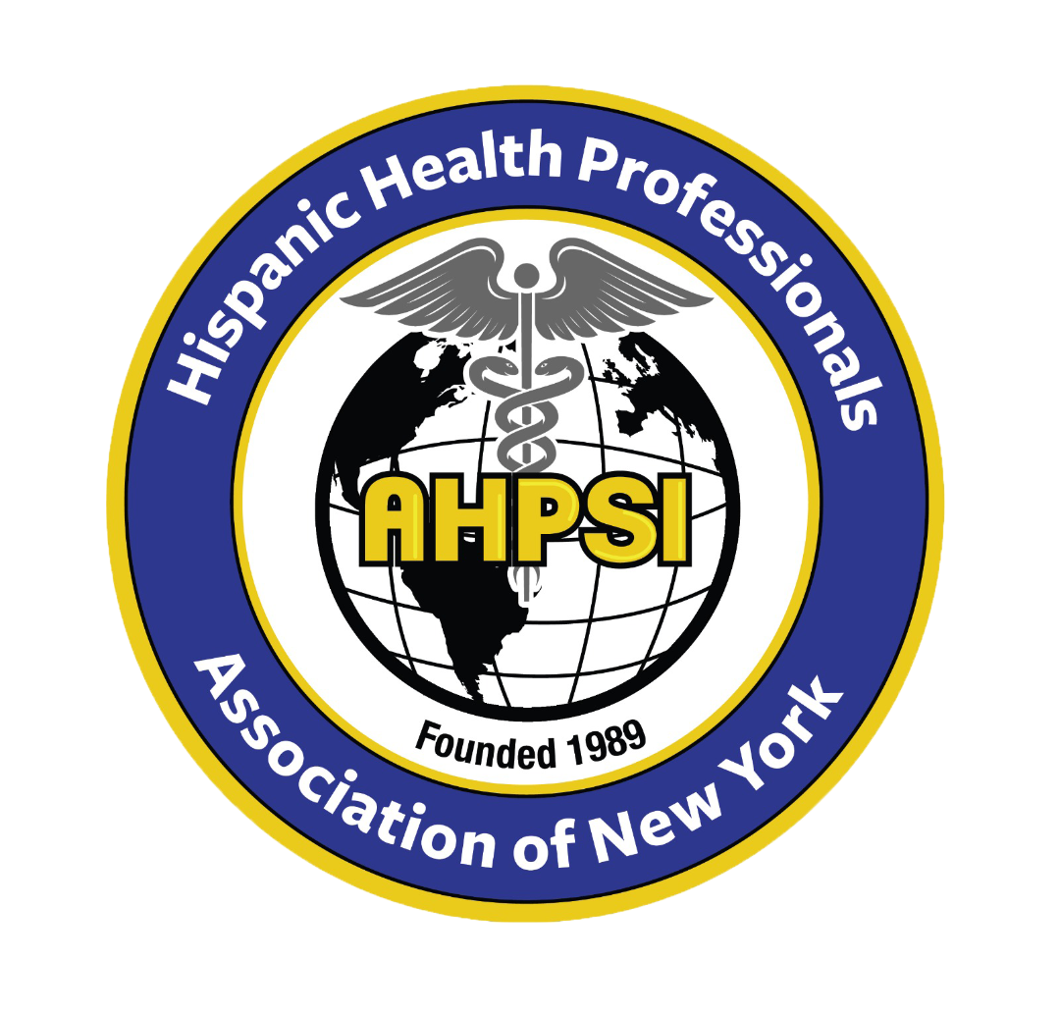  Dr.Aritmedes Restituyo.  President  Eliscer Guzman,MD  President ad vitam.  Carlos Williams, MD  Chairman  Licda.Paulina De León.  Miembro  Dra.Leonor Tavarez.  Member.  Dra.Carmen Rodriguez.  Member.  Lic.Gilberto Cruz.  Union County Dominican Parade and Festival  Licda.Elba Rosa Garcia.  Secretary.  732-277-9640  resti1@aol.com  info@ahpsi.org  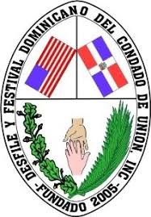 | Hispanic Health professionals association, Inc NY  Over 35 years of service.  Union County Dominican Parade and Festival.  May 17, 2024  Dear :To Our Valued Sponsor,  We are delighted to announce the organization of our XI Annual Health Fair, themed "Decide to be Healthy," scheduled for Sunday, July 21, 2024, from 9:00 AM to 4:00 PM. This significant event will be held at the Juan Pablo Duarte & Jose Marti School, located at 25 First Street, Elizabeth, New Jersey.  For the past 11 years, our health fair has been instrumental in saving lives and promoting health awareness within our community. This year, we will continue to offer a range of services, including medical exams, dental exams, conferences, demonstrations, and workshops.  To make this event a success, we are reaching out to our valued sponsors for support. Enclosed with this letter, you will find detailed information about the various sponsorship levels available. Your generous donation will enable us to better meet our objectives and provide essential health services to those in need.  We are thrilled to have the opportunity to host this event once again and deeply appreciate your continued support. The deadline to receive your donation is July 10, 2024.  Thank you for your consideration and generosity.  Sincerely,  Dr. Aritmedes Restituyo  Lic. Gilberto Cruz , 908-347-4609  info@ahpsi.org  732-277-9640

