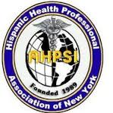
Desfile y festival Dominicano condado de Union,New Jersey. 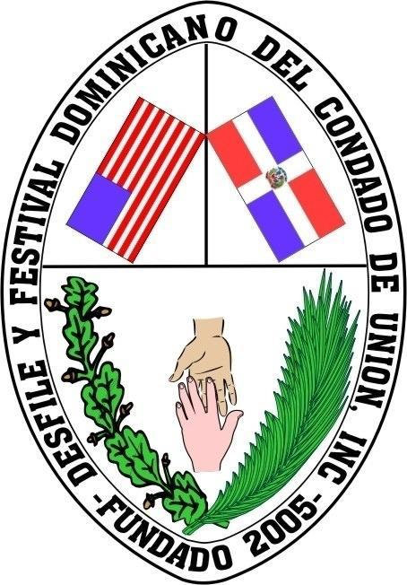
& HISPANIC HEALTH PROFESSIONALS ASSOCIATION, INC, NY
XI Annual Community Health Fair “Decide to Be Healthy”
Location: Juan Pablo Duarte & Jose Marti
25 First St, New Jersey 07206

Confirmation Form/ Hoja confirmación
Join Us in Promoting Health and Wellness!

We are thrilled to announce that registrations are now open for organizations offering health-related services at our upcoming health fair. This is a wonderful opportunity to make a meaningful impact on our community and help us in our mission to promote health and wellness.

Why Participate?

For over 11 years, we have been dedicated to saving lives and improving health outcomes. Your participation can greatly enhance our efforts and provide invaluable services to attendees who need them the most.
Services We Are Looking For:
We invite organizations to offer a variety of health-related services, including but not limited to:

Health Screenings: Blood pressure, glucose, cholesterol,Nutrition and Exercise: Dietary advice, fitness tips, exercise demonstrations,Counseling Services: Mental health support, stress management, addiction counseling,Dental Care: oral hygiene education,Cancer Screenings: Mammograms, prostate exams, skin checks,Mental Health Services: Therapy sessions, mental health evaluations, support groups

Date: Sunday, July 21 2024. Time: 9:00 A.M. to 3:00 P.M.

Dr. Aritmedes . Restituyo (732) 277-964
info@ahpsi.org efax: 732-725-0868.

Please Complete this Form and Return by Friday, July 12, 2024

- Yes, I will attend | - Health Related Services
- No, I will not attend | - Mini Conference
- Need Table and Chairs  - Need Electrical Outlet | - Education
 | - Cultural Entertainment
 | - Mobile services

What are your Requirements?
Name: Contact email:

