Hispanic Health Professionals Association, Inc NY & Dominican parade and festival, Union County,

XI ANNUAL HEALTH FAIR “DECIDE TO BE HEALTHY”

SPONSORSHIP OPPORTUNITIES

Sunday, July , 21, 2024
9:am-4pm.

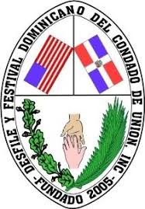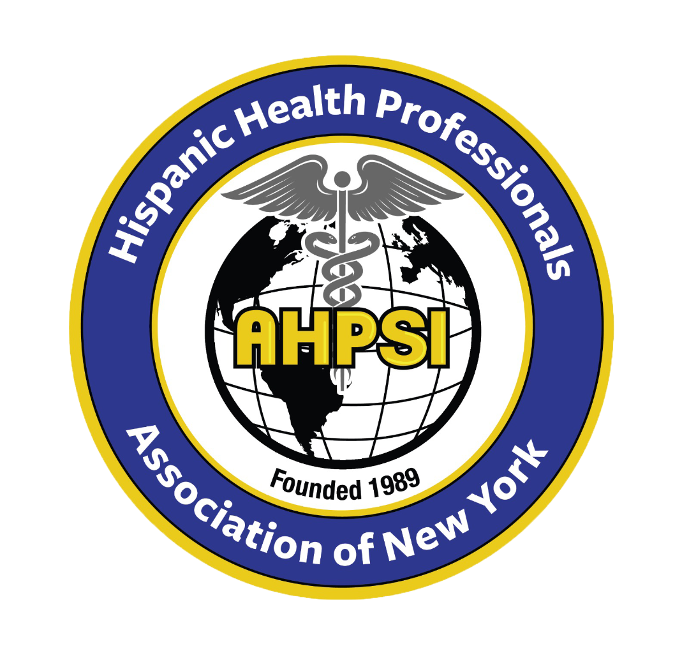

There are four levels of sponsorship available for this event:

- DIAMOND ($2,000).
Sponsor Benefits:
•Only your enterprise will be announced during the Health Fair.
•10 tickets to attend the post event, “The Flavor of Perth Amboy,” including 5-10 minutes to address around 150 participants (Public Officials, Community and Religious Leaders, and a wide variety of Professional citizens).
• 5-10 minutes presentation during the inaugural ceremony, which is the key event of our “Decide to Be Healthy” Fair.
•Display of your chosen sign both at the Cafeteria and the Gym’s entrance.
•Free distribution of your chosen literature by our team of Volunteers from the High Schools of Perth Amboy.
•Display of your enterprise’s logo in all the pages of www.ahpsi.org (Hispanic Health Professional. Association) as soon as a pledge is committed.
•Banner of your enterprise with logo and message welcoming attendees.
•All Press Releases of the Health Fair will display your enterprise’s support.
•5-7 minutes interview in the video of our “2024 Health Fair Memory Video”
•To include a flier of your enterprise in the bag handed during the Health Fair.

B. PLATINUM ($1,000). Sponsor Benefits:
* Banner Display at Luncheon * VIP Seating five (5) at Welcome Ceremony
• VIP Seating ten (10) at Welcome Reception * Corporate logo on all collateral.
• Corporate logo on all collateral * Corporate logo on press release.
•• Display table at business luncheon.
• Display of your chosen sign both at the Cafeteria
•1 Raffle with one mention by our Masters of Ceremonies.
•5 tickets to attend a post event, “The Flavor of Elizabeth ,” including 5-10 minutes to address around 150 participants (Public Officials, Community and Religious Leaders, and a wide variety of Professional citizens).
••Two 6 foot tables.
•2-3 minutes in our “2024 Health Fair Memory Video”
•To include a flier of your enterprise in the bag handed during the Health Fair.

C. GOLD ($500). Sponsor Benefits:
• VIP Seating three (3) at Luncheon Reception.
• VIP Seating five (5) at Welcome Reception
• Two (2) conference Registrations.
• Corporate logo on all collateral
• Mention on 2 press releases.
• Display a 6 foot table at business luncheon
• Corporate logo on all collateral.
•One 6 foot table.
•1-2 minutes in our “2024 Health Fair Memory Video”
•To include a flier of your enterprise in the bag handed during the Health Fair.

D. Bronze ($250). Sponsor Benefits:
•One (1) VIP Seating at Luncheon Reception.
•2 VIP Seating at Welcome Reception.
•1 mention in 1 (one) press release.
•Display a 6 foot table at a business luncheon.
•Auto presentation of your enterprise in the “2024 Health Fair Memory Video”
•Your enterprise may have a flier included in the bag handed during the Health Fair.

Make your check payable to TO
AHPSI
61 Brighton ave, Perth amboy, New Jersey, 08861
Before, july 10, ,2024 .Dr.Aritmedes Restituyo, 732-277-9640, info@aphsi.org
Mr.Gilberto Cruz, 908-347-4609

