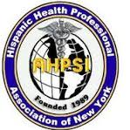
Desfile y festival Dominicano condado de Union,New Jersey. 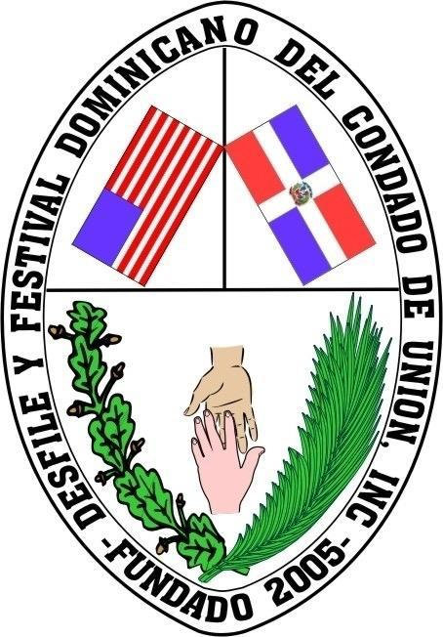
& HISPANIC HEALTH PROFESSIONALS ASSOCIATION, INC, NY
XI Annual Community Health Fair “Decide to Be Healthy”
Location: Juan Pablo Duarte & Jose Marti
25 First St, New Jersey 07206

Confirmation Form/ Hoja confirmación
Join Us in Promoting Health and Wellness!

Calling All Health Professionals! Join Our Community Health Fair
Registration is now open! We're seeking organizations offering health-related services to participate in our upcoming fair. It's a fantastic opportunity to make a positive impact and promote health & wellness in our community.
Why Partner with Us?
For over 11 years, we've been dedicated to improving lives. Your participation allows us to offer vital services to those who need them most.
Services We Need:
- Health Screenings (blood pressure, glucose, cholesterol)
- Nutrition & Exercise (dietary advice, fitness tips)
- Counseling Services (mental health, stress management, addiction)
- Dental Care (oral hygiene education)
- Cancer Screenings (mammograms, prostate exams, skin checks)
- Mental Health Services (therapy, evaluations, support groups)
Join us and make a difference!
Date: Sunday, July 21 2024. Time: 9:00 A.M. to 3:00 P.M.

Dr. Aritmedes . Restituyo (732) 277-964
info@ahpsi.org efax: 732-725-0868.

Please Complete this Form and Return by Friday, July 12, 2024

- Yes, I will attend | - Health Related Services
- No, I will not attend | - Mini Conference
- Need Table and Chairs  - Need Electrical Outlet | - Education
 | - Cultural Entertainment
 | - Mobile services

What are your Requirements?
Name: Contact email:

